Python API Integration and JSON Data Handling
Task Report
Learn how Python communicates with external APIs and handles JSON data

1. Objective
The objective of this task is to learn how Python communicates with external APIs using the Requests library. The task also demonstrates how to parse JSON responses, filter API data, and handle API errors using Python.

2. Tools and Technologies
- Python
- Requests Library
- JSON
- REST API
- Visual Studio Code
- Command Prompt

3. API Used
API: JSONPlaceholder
Endpoint: https://jsonplaceholder.typicode.com/users
Method: GET
JSONPlaceholder is a free fake REST API used for testing and learning. The Users endpoint was used to retrieve user information in JSON format.

4. Step 1 – Import Requests Library
Code:
import requests
The Requests library is used to send HTTP requests from Python. It allows Python to communicate with external APIs.
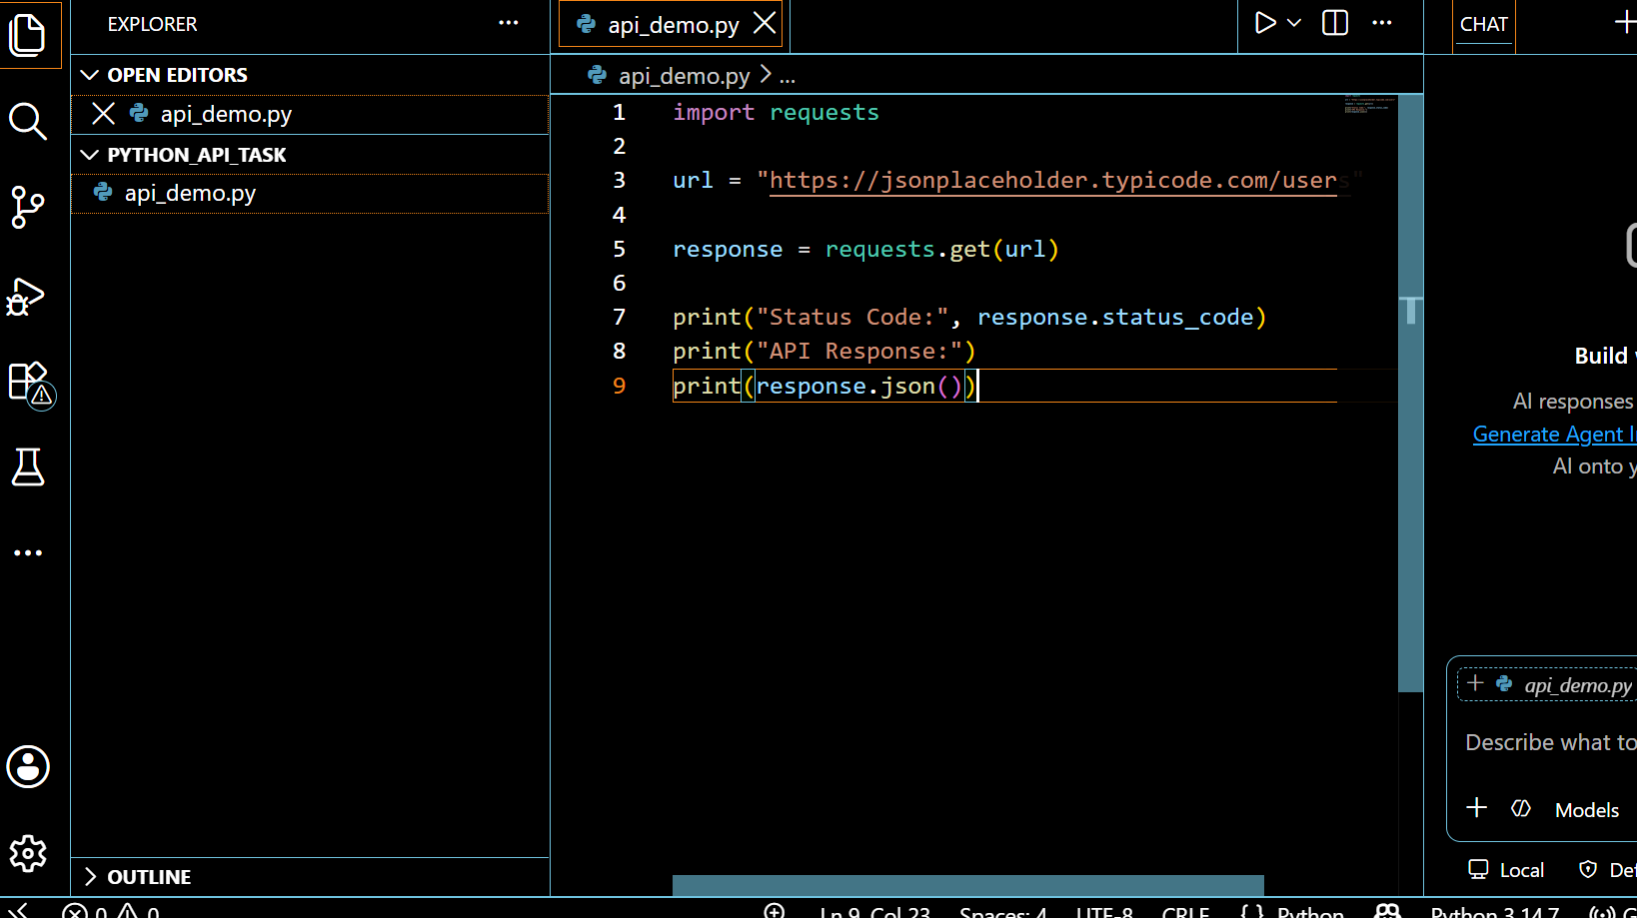
Screenshot 1 – Complete Python API Code

5. Step 2 – Fetch Data from the API
The program stores the API URL and sends a GET request:
url = "https://jsonplaceholder.typicode.com/users"
response = requests.get(url, timeout=5)
The requests.get() method sends a GET request to the API and receives the response. A status code of 200 indicates that the request was successful.
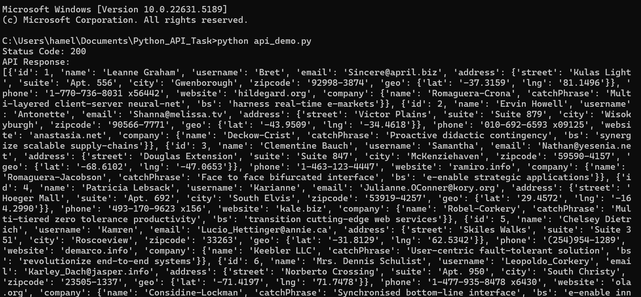
Screenshot 2 – API Fetch Output

6. Step 3 – Parse the JSON Response
The JSON response is converted into Python data using:
users = response.json()
The response.json() method converts the JSON response received from the API into Python data that can be processed using loops and conditions. The program then extracts each user's name and email.
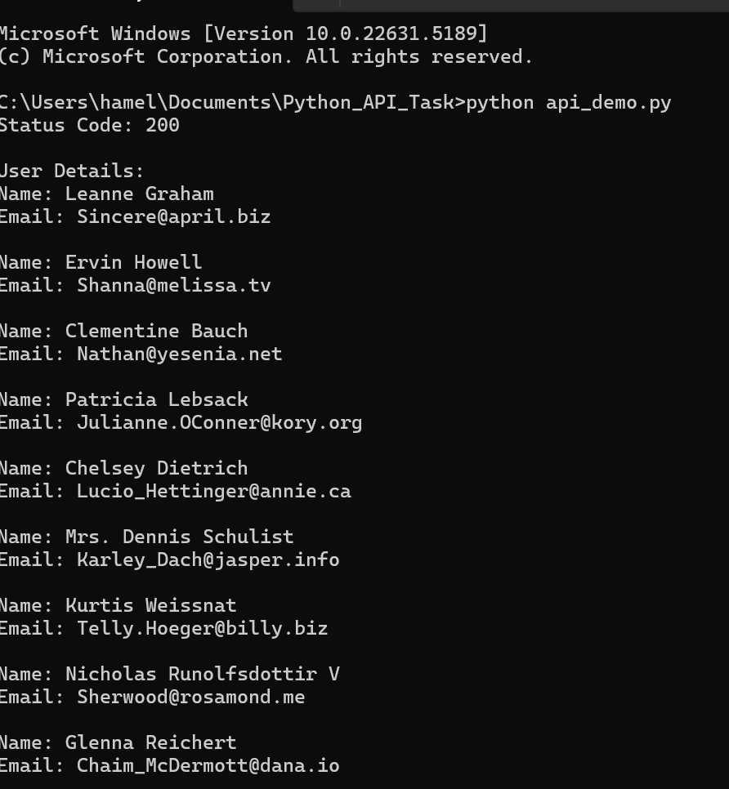
Screenshot 3 – JSON Parsing Output

7. Step 4 – Filtering / Search Logic
The program searches for a specific user name:
search_name = "Leanne"
if search_name.lower() in user["name"].lower():
The filtering logic checks whether the search text appears in the user's name. The lower() method makes the comparison case-insensitive.
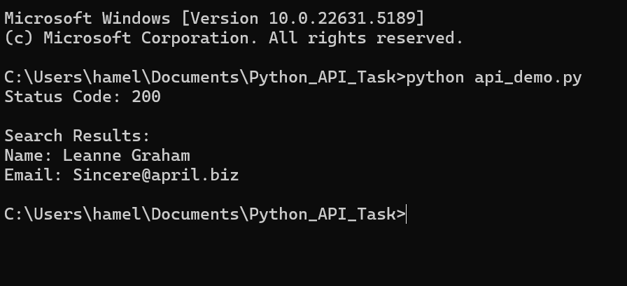
Screenshot 4 – Filtering / Search Output

8. Step 5 – API Error Handling
The program uses try-except to safely handle API connection or HTTP errors. raise_for_status() checks whether the server returned an HTTP error, while RequestException catches request-related errors.
try:
response = requests.get(url, timeout=5)
response.raise_for_status()
except requests.exceptions.RequestException as error:
print("API Error:", error)
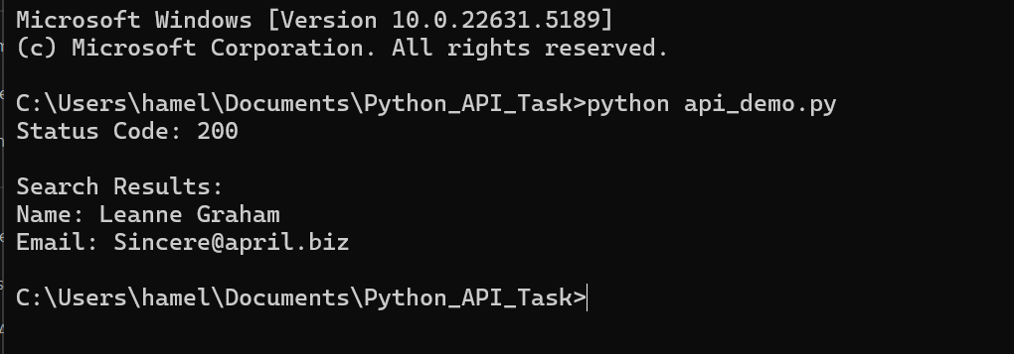
Screenshot 5 – API Error Handling Output

9. Complete Working API Script
import requests
url = "https://jsonplaceholder.typicode.com/users"
try:
response = requests.get(url, timeout=5)
response.raise_for_status()
users = response.json()
search_name = "Leanne"
print("Status Code:", response.status_code)
print("\nSearch Results:")
for user in users:
if search_name.lower() in user["name"].lower():
print("Name:", user["name"])
print("Email:", user["email"])
except requests.exceptions.RequestException as error:
print("API Error:", error)
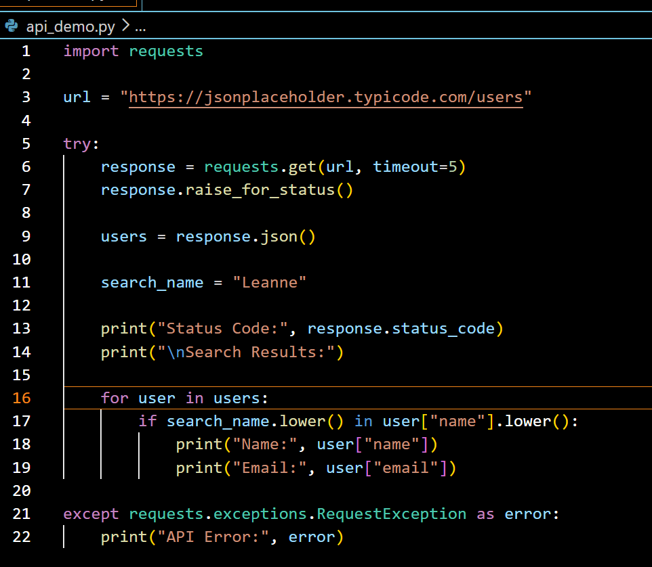
Screenshot 6 – Final Complete Code

10. Requirements Checklist
Requirement | Status
Fetch data using Requests library | ✓ Completed
Parse JSON responses | ✓ Completed
Apply filtering or search logic | ✓ Completed
Handle API errors | ✓ Completed
Working API script | ✓ Completed
Output screenshots with explanation | ✓ Completed

11. Conclusion
This task demonstrated how Python can communicate with external APIs using the Requests library. The API response was successfully retrieved and converted from JSON into Python data. Filtering logic was applied to search for a specific user, and API errors were handled using exception handling. Therefore, all the required API integration and JSON handling concepts were successfully implemented.

